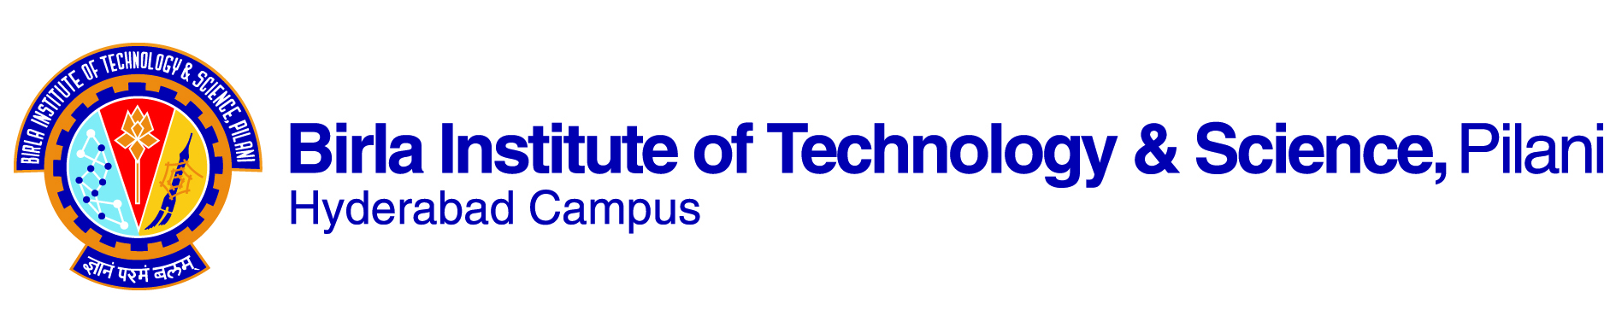

**SECOND SEMESTER 2019-2020**

# Course Handout Part II

Date: 06-01-2020

In addition to part-I (General Handout for all courses appended to the time table) this portion gives further specific details regarding the course.

*Course No.* : GS F245

Course Title : Effective Public Speaking

## Instructor-in-Charge : M.G.Prasuna

**Scope and Objective of the Course:**

This course aims to improve the students’ speaking skills in various professional contexts and enable them to develop the art of public speaking. The course is practice-oriented and is designed to develop the necessary skills through actual practice in presenting information, giving seminars, participating in group talk etc. Students will develop the fundamentals of communication and develop skills in the preparation, organization and presentation of speeches. Students practice and deliver prepared and impromptu speeches, to inform, to persuade and to entertain.

The main objectives of the course are to enable learners to:

* Use verbal and nonverbal communication to enhance their speech.
* Overcome the fear of speaking in front of an audience
* Deliver organized and effective oral presentations for diverse audiences and varied purposes.
* Examine language appropriate for purpose and audience
* Practice oral presentations to gain fluency, to adjust tone and modulate volume for emphasis,

and to develop poise.

* Use peer feedback for self-evaluation.

**Textbooks:**

1. Lata, Pushp and Kumar Sanjay. *Communicate or Collapse: A Handbook of Effective Public Speaking, Group Discussions and Interviews* OUP 2011.

**Reference books**

1. Lucas, Stephen E. *The Art of Public Speaking*. Third Edition, Singapore: McGraw-Hill, 1989.

2. Deanna D Sellnow. *Public Speaking: A Process Approach.* Media Edition, Thomson/ Wadsworth, 2003.

3.Prague, Jo and Stuart, Douglas. *The Speaker’s Handbook*. Sixth Edition, USA. Thomson/ Wadsworth, 2003.

**Course Plan:**

|  |  |  |  |
| --- | --- | --- | --- |
| **Lecture No.** | **Learning Objectives** | **Topics to be Covered** | **Chapter in the book** |
| 1-2 | Understand and reflect upon the idea of Public Speaking and its significance to professionals. | Public Speaking: An Overview | 1&2 |
| 3-4 | Critically evaluate the importance of listening for effective speaking. | Importance of Listening and Speaking Skills | 3 |
| 5-10 | Understand communication apprehension (CA) and tools to overcome CA.  Develop speeches that can increase self-confidence and credibility. | Credibility, Confidence and Combating nervousness. | 2 |
| 11-15 | Understand the steps involved in preparing a public speech. | Preparation of speech & Audience Analysis | 5 |
| 16-19 | Research and organize material to achieve the goals of a speech | Organization of speech | 5 |
| 20-25 | Understand how to prepare, rehearse and present a speech | Platform Manners & Use of Microphones | 6&7 |
| 26 -29 | Identify the characteristics of different modes of presentation | Modes of Delivery | 7,14 |
| 30-31 | Demonstrate ability to prepare and manage visual aids effectively | Use of Visual Aids | 8 |
| 32-34 | Apply the use of persuasive language that makes the audience to accept one’s position. | Psychology of Persuasion | 13 |
| 35-37 | Explore the different nuances involved in the speeches for different occasions such as welcome speech, felicitation speech, keynote address vote of thanks, welcome speech, vote of thanks etc. | Speeches for Special Occasions | 11 |
| 38-42 | Practice adequately various aspects of public speaking and other speaking skills | Speech Practice | 15 |
|  |  |  |  |

**Evaluation Scheme:**

|  |  |  |  |  |
| --- | --- | --- | --- | --- |
| **Component** | **Duration** | **Weightage (%)** | **Date & Time** | **Nature of Component** |
| Assignment-I |  | 15% | TBA |  |
| Mid-Semester Exam | 90 minutes | 30% | 3/3 3.30 - 5.00 PM | Written-closed book |
| Assignment-II |  | 15% | TBA |  |
| Comprehensive Exam | 3 hours | 40% |  | Oral |

**Chamber Consultation Hour:** To be announced in the class.

**Notices:** Notices, if any, will be displayed on the HSS notice Board in K block.

**Make-up Policy:** Make-up will be given only in genuine cases (subject to verification).

**Academic Honesty and Integrity Policy:** Academic honesty and integrity are to be maintained by all the students throughout the semester and no type of academic dishonesty is acceptable.

**M G Prasuna**

**INSTRUCTOR-IN-CHARGE**